**GOA FAMOUS FOODSPOTS**

**Eat local**  
Goa has several excellent restaurants which represent the culinary diversity of the state. Among the best is Panaji's Mum's Kitchen, which offers a mix of familiar dishes like xacuti (a curry with coconut, spices and poppy seeds), balchao (a fiery tomato-chilli curry) and cafreal (fried chicken marinated with spices). Its menu comprises of traditional recipes, which have been sourced from Hindu, Christian and Portuguese families from all over Goa. Another good bet in Panaji is Ritz Classic, whose Goan Fish Thali offers seafood delights such as prawn curry, prawn kishmur, crab masala and shellfish with coconut.

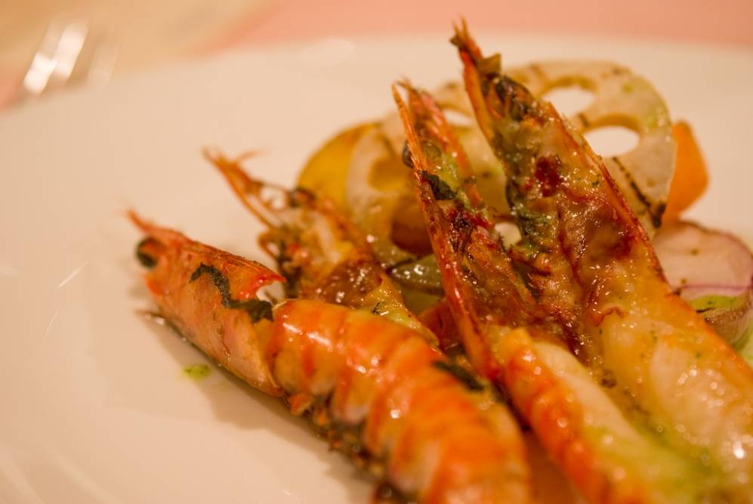[Photo by:](http://www.flickr.com/photos/36521954194@N01/3049988931/in/)  [cipher], [Creative Commons Attribution Licence](http://creativecommons.org/licenses/by/2.0/deed.en)

Calangute's immensely popular Souza Lobo is a veteran among Goan restaurants. This sea-facing eatery's crab xacuti, lobster thermidor and prawn curry rice are highly recommended. For home-style cooking, head to Bhatti village in Nerul, where you won't find a menu but will be assured of fresh and flavourful food and warm Goan hospitality. Located in the owners' residence, it is only open for dinner.  
  
[**Mum's Kitchen**](http://www.happytrips.com/goa/mums-kitchen/ps23969332.cms)**:**House No. 854, Ground Floor, Martin's Building, DB Marg, Near Times Of India Office, Miramar, Goa 403001. Phone: +91-9822175559, +91-9822175556  
  
**Viva Panjim:**First Floor, Wagle Vission Building, 18th June Road, Near National Theatre, Panaji, Goa 403001. Call: +91-832-6644796

[**Souza Lobo**](http://www.happytrips.com/goa/souza-lobo/ps38547242.cms)**:**Calangute Beach, Bardez, Goa, 403516. Phone: +91-832-2281234, +91-832-2276463  
  
**Bhatti Village:**Bhatti Waddo, Nerul, The Sol Hotel, Bardez, Goa 403114 Phone: +91-9822184103

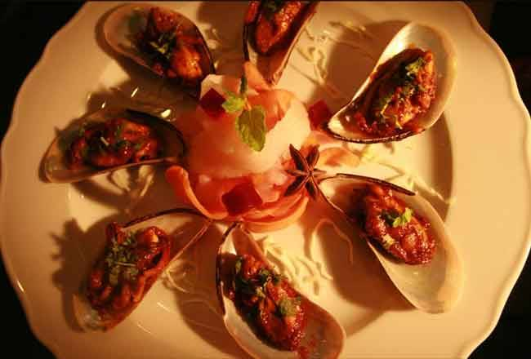Photo courtesy: Mum's Kitchen

**Dine like royalty**  
For an aristocratic experience, head to Palacio do Deao, a restored 18th-century palace in Quepem, Chandor. Once the home of the town's founder, the mansion is located on the banks of the Kushavati River and surrounded by lush gardens. Its restaurant serves vegetarian and non-vegetarian dishes from the kitchens of the Indo-Portuguese aristocracy, in beautiful surroundings. The prixe fixe lunch includes seasonal delicacies cooked with fresh local vegetables, fruits and fish. Don't forget to ask for their delicious homemade bebinca, a layered dessert made with eggs and coconut milk.  
  
**Palacio do Deao:**Opposite Holy Cross Church, Quepem, Goa 403705. Phone: +91-832-2664029, +91-9823175639

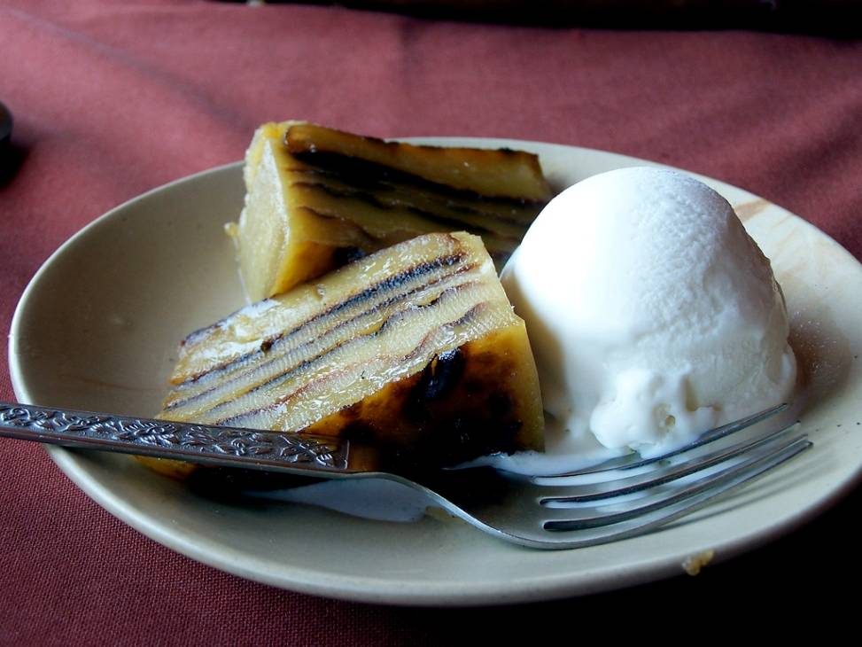[Photo by:](http://www.flickr.com/photos/wnorrix/120223072)  Warren Noronha, [Creative Commons Attribution Licence](http://creativecommons.org/licenses/by/2.0/deed.en)

**Take a spice plantation tour**  
Several spice plantations clustered around Ponda in South Goa offer an introductory tour, followed by a traditional lunch. This is an interesting way to learn about the organic cultivation of spices such as pepper, cinnamon, cardamom and nutmeg; trees such as cashew and areca nut; and fruits such as jackfruit, custard apple, mango and pineapple. There are three major spice plantations in this area: the Tropical Spice Plantation, the Savoi Plantation and the Sahakari Spice Farm. The Savoi Plantation offers Goan Saraswat cuisine, which makes extensive use of kokum, tamarind and coconut. Tour highlights include a visit to its cashew processing factory and feni distillation unit, as well as a demonstration of betel-nut plucking.  
  
**Savoi Plantation:**Ponda, Goa 403401. Phone: +91-832-2340272  
  
[**Sahakari Spice Farm**](http://www.happytrips.com/goa/sahakari-spice-farm/ps40904406.cms)**:**Ponda Belgaum Highway, Curti, Ponda, Goa 403401. Phone: +91-832-2312394  
  
**Tropical Spice Plantation:**House No. A-14, Arla Bazaar Keri, Ponda, Goa 403401. Phone: +91-832-2340329

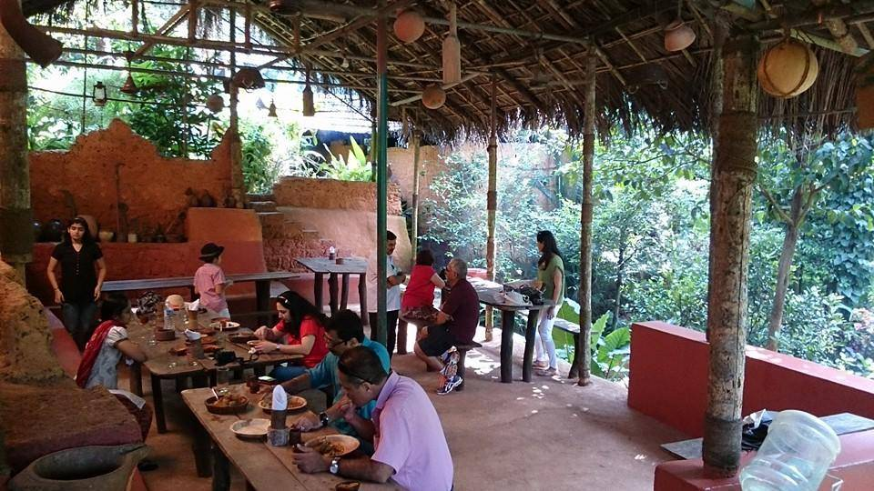Photo courtesy: Savoi Plantation

**Cook like a Goan**  
If your passion for food goes beyond eating, enrol yourself at the Siolim Cooking School to discover a few local culinary secrets. The classes are conducted at Siolim House, a heritage hotel in Bardez. Participants are taken to a market, introduced to local spices and ingredients, and given insights into the cultural and religious importance of food. They are also taught well-known Goan dishes such as chicken cafreal, pork sorpotel (a spicy curry of vinegar and chillies), xacuti and fish curry. Siolim House also runs cooking holidays for hotel guests.  
  
**Siolim House:**Wadi, Siolim, Goa 403517. Call: +91-9604887740, +91-832-2272138, +91-832-2272941

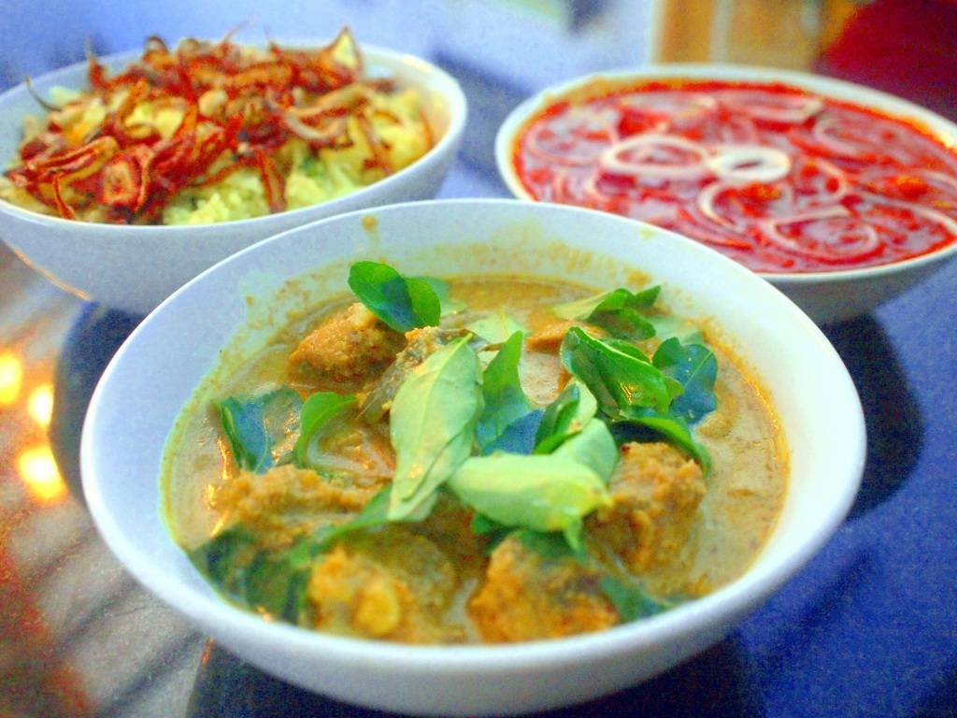Photo courtesy: Siolim House

**Visit old Goan bakeries**  
Goa has a long and vibrant tradition of bread-making. Popular local breads include uned (small, round and crispy breakfast rolls), pao (round buns) and pui (flat, pancake-like rolls). To taste, visit a local bakery like Panaji's family-run Confeitaria 31 De Janeiro, which is also one of the oldest in Goa. Besides bread, it has mouth-watering savoury patties and traditional sweets like dodol (an eggless cake of rice flour, coconut and jaggery), pinaca (balls of rice flour, coconut and jaggery) and doce (squares made with lentils, coconut and cardamom). Jila Bakers, another veteran, operates out of an old house in Loutolim, and is widely considered to be one of the best bakeries in the state. Their breads, biscuits and pastries are made by hand and baked in a wood-fired oven, using traditional techniques. Try their melt-in-the-mouth cookies called suspiros, and the crisp and flaky heart-shaped fan biscuits.

KERALA

**1. Shala Restaurant**

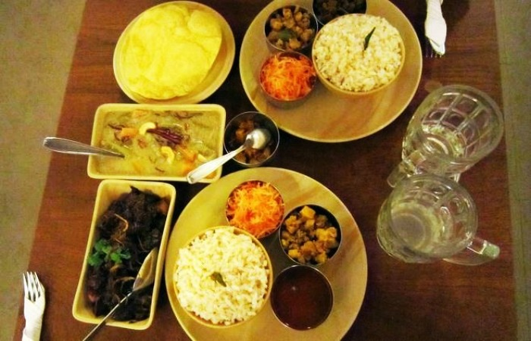**[http://d2847ql9t214mi.cloudfront.net/wp-content/themes/harmony/img/click1.png](javascript:void(0))**

Literally, Ma ke haath ka khaana! The very USP of this place is home cooked food by the local housewives. So, you can expect delicious home cooked food in a lovely set up. It’s a small place and it shouldn’t come as a surprise if you see a long queue waiting outside to get a table here.

**Speciality:** Malabar prawn curry, kingfish steak, and the vegetarian special (which changes daily)  
**Location:** Peter Celli Street, Fort Kochi, Kochi  
[Ratings / Reviews on Zomato](https://www.zomato.com/kochi/shala-1-fort-kochi)

**2. Rahmathullah Hotel**

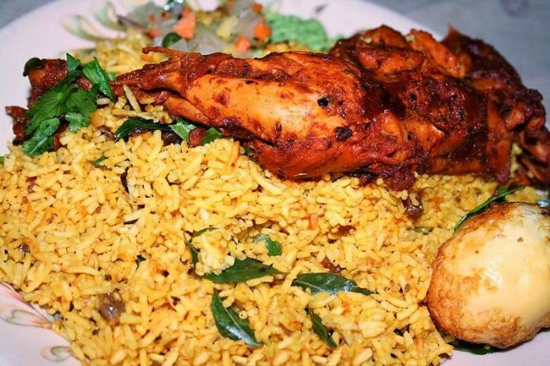**[http://d2847ql9t214mi.cloudfront.net/wp-content/themes/harmony/img/click1.png](javascript:void(0))**

Don’t go by the looks of this little place because if you want to have the best biryani in Kerala you’ll have to bear with it! Kayee’s Rahmathullah Hotel has been serving since 1948 and everyday people from all across line up here to have a taste of their delectable biryani.

**Speciality:** Biryani, Fridays you get fish Biryani and on Tuesdays, prawn. On all the other days chicken and mutton is available.  
**Location:** Aanavaadal, Fort Kochi, Mattancherry, Kochi  
**Ratings:** 5 star  
[Ratings / Reviews on TripAdvisor](http://www.tripadvisor.in/Restaurant_Review-g297633-d2227230-Reviews-Kayees_Rahmathullah_Hotel_Restaurant-Kochi_Cochin_Kerala.html)

**3. Kethal’s Chicken**

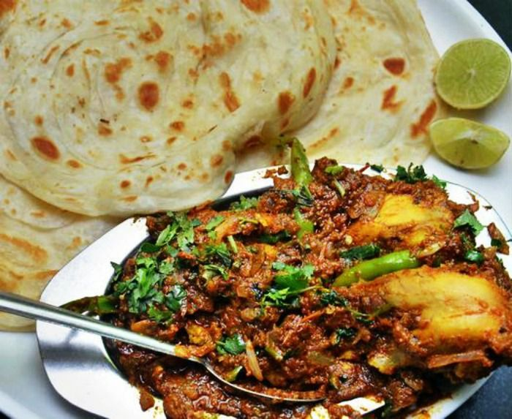**[http://d2847ql9t214mi.cloudfront.net/wp-content/themes/harmony/img/click1.png](javascript:void(0))**

Forget KFC, its KCF or Kethal’s Chicken Fry that you must try! Operating since 1949, this is an amazing place that’s been serving Kerala’s favourite fried chicken.

**Speciality:** Chapppathi and chicken fry with lime juice sprinkled on it  
**Location:** Rahmaniya Lane, Chalai Bazar,Trivandrum  
**Ratings:** 4 stars  
[Ratings / Reviews on TripAdvisor](http://www.tripadvisor.in/Restaurant_Review-g297637-d3977916-Reviews-Kethels_Chicken-Thiruvananthapuram_Trivandrum_Kerala.html)

**4. Rapsy Restaurant**

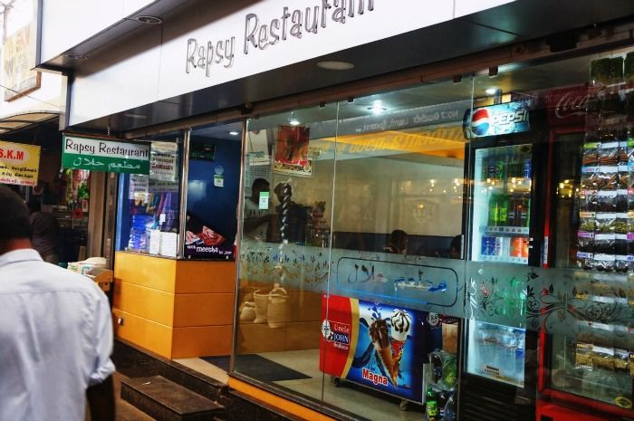**[http://d2847ql9t214mi.cloudfront.net/wp-content/themes/harmony/img/click1.png](javascript:void(0))**

While on a backpack trip with a tight budget, Rapsy Restaurant is your answer to delicious food at cheap rates. Prices for Rapsy’s famous paratha or biryani starts at just Rs. 50!

**Speciality:** Spanish omelette, Israeli shakshuka (eggs with tomatoes and spices) and Mexican salsa.  
**Location:** Main Bazaar, Munnar  
**Ratings:** 4 stars  
[Ratings / Reviews on TripAdvisor](http://www.tripadvisor.in/Restaurant_Review-g303881-d2634677-Reviews-Rapsy_Restaurant-Munnar_Kerala.html)

**5. Grand Pavilion**

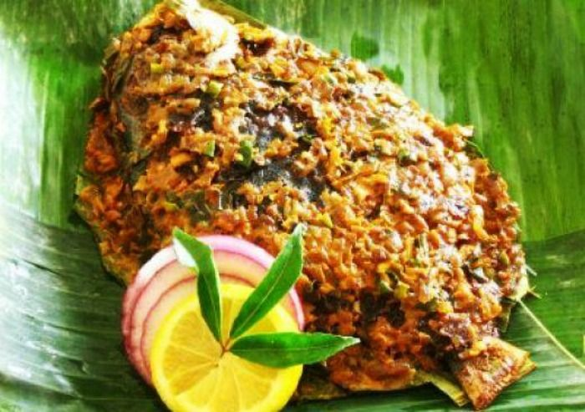**[http://d2847ql9t214mi.cloudfront.net/wp-content/themes/harmony/img/click1.png](javascript:void(0))**

The Grand Pavilion is one of the oldest and most popular eatery in Kochi. If you can get past the crowd and find yourself a table in here, you are in for a gourmet’s delight.

**Speciality:** Syrian food, the Karimeen Pollichathu (fried pear spot fish), Seafood, Biriyani, and authentic Keralan dishes  
**Location:** Ernakulam, Kochi  
**Ratings:** 5 stars  
[Ratings / Reviews on TripAdvisor](http://www.tripadvisor.in/Restaurant_Review-g297633-d2371824-Reviews-Grand_Pavilion-Kochi_Cochin_Kerala.html)

**Suggested Read:** [10 Beaches In Kerala You Should Visit For A Romantic Vacation](http://traveltriangle.com/blog/romantic-kerala-beaches/)

**6. Menorah**

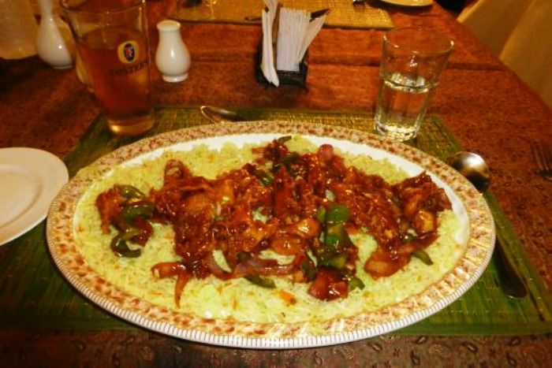**[http://d2847ql9t214mi.cloudfront.net/wp-content/themes/harmony/img/click1.png](javascript:void(0))**

The nearby beach adorned with the huge Chinese fishing nets ensures a steady supply of fresh fishes and other sea food at Menorah. No wonder they serve the best sea food in town!

**Speciality:** Jewish food and sea food  
**Location:** Koder House, Fort Cochin, Kochi  
**Ratings:** 3.5 stars  
[Ratings / Reviews on Zomato](https://www.zomato.com/kochi/menorah-fort-kochi/reviews)

**7. Hotel Annapoorna**

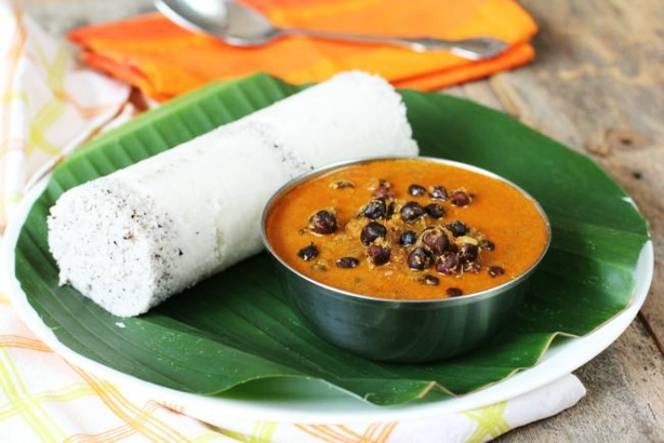**[http://d2847ql9t214mi.cloudfront.net/wp-content/themes/harmony/img/click1.png](javascript:void(0))**

All the vegans out there may rejoice! Hotel Annapoorna is a pure veg restaurant serving the best Mallu breakfast and other traditional food.

**Speciality:** Puttu, Masala Dosa, Idli (all veggie favourites, just name it)  
**Location:** Perumbavoor, Kerala  
**Ratings:** 4.5 stars  
[Ratings / Reviews on TripAdvisor](http://www.tripadvisor.in/Restaurant_Review-g297637-d4935425-Reviews-Hotel_Annapoorna-Thiruvananthapuram_Trivandrum_Kerala.html)

**8. Dal Roti**

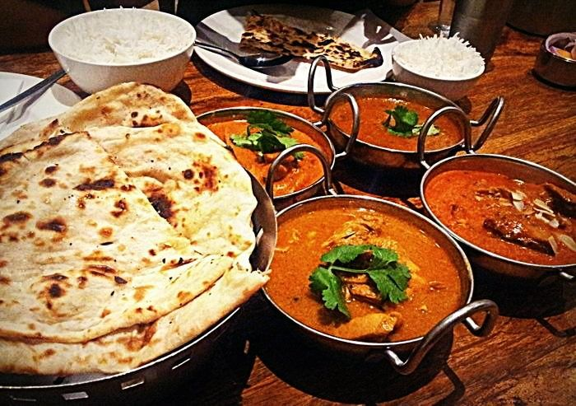**[http://d2847ql9t214mi.cloudfront.net/wp-content/themes/harmony/img/click1.png](javascript:void(0))**

Are you missing your tandoori chicken, roti and dal makhni? Well, if you want a break from the coconutty, spicy and tangy local flavours of Kerala, step in to Dal Roti.

**Speciality:** North Indian food, Kathi rolls  
**Location:** Fort Kochi, Kochi  
**Ratings:** 4 stars  
[Ratings / Reviews on TripAdvisor](http://www.tripadvisor.in/Restaurant_Review-g297633-d815885-Reviews-Dal_Roti-Kochi_Cochin_Kerala.html)

***Cafes, Shacks and a Continental Breakfast***

**[http://d2847ql9t214mi.cloudfront.net/wp-content/themes/harmony/img/click1.png](javascript:void(0))**

Oh, don’t you worry; you won’t be deprived of a fine Continental meal here in Kerala. The fact that it’s a diverse state with a variety of international influences can be clearly seen in their food.

Let’s look at some of the best places for continental food in Kerala:

**9. Beatles Restaurant**

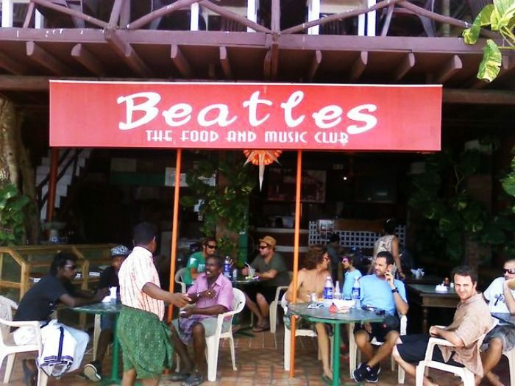**[http://d2847ql9t214mi.cloudfront.net/wp-content/themes/harmony/img/click1.png](javascript:void(0))**

Just like the name, the place is equally amazing. Overlooking the breathtaking Lighthouse beach, this restaurant invites a huge number of tourists who come here for laid back time out. The tiger prawns served here are to die for!

**Speciality:** Burgers, Seafood and continental breakfast  
**Location:** Lighthouse Beach, Kovalam  
**Ratings:** 4 stars  
[Ratings / Reviews on TripAdvisor](http://www.tripadvisor.in/Restaurant_Review-g311295-d1750129-Reviews-Beatles_Restaurant-Kovalam_Kerala.html)

**Suggested Read:** [10 Beaches In Kerala You Should Visit For A Romantic Vacation](http://traveltriangle.com/blog/romantic-kerala-beaches/)

**10. Indian Coffee House**

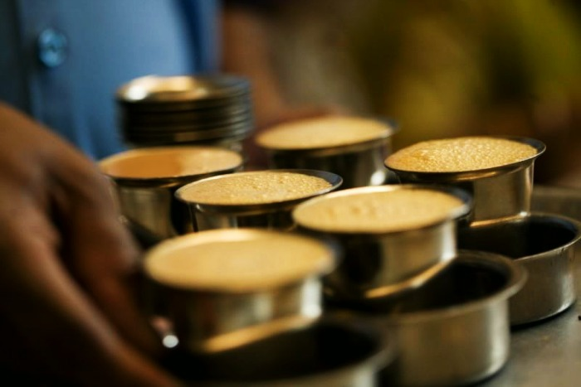**[http://d2847ql9t214mi.cloudfront.net/wp-content/themes/harmony/img/click1.png](javascript:void(0))**

A flamboyant, spirally red brick tower, in the central station road of Trivandrum attracts flocks from all corners of the town. It’s the oldest and the biggest chain of restaurant in all of Kerala- The Indian Coffee House. A refreshing cup of filter coffee with a side of dosa or idli is just the way to begin the day in Trivandrum!

**Speciality:** Coffee and snacks  
**Location:** Central Station Road, Trivandrum  
**Ratings:** 4 stars  
[Ratings / Reviews on TripAdvisor](http://www.tripadvisor.in/Restaurant_Review-g297637-d1202065-Reviews-Indian_Coffee_House-Thiruvananthapuram_Trivandrum_Kerala.html)

**11. Kashi Art Café**

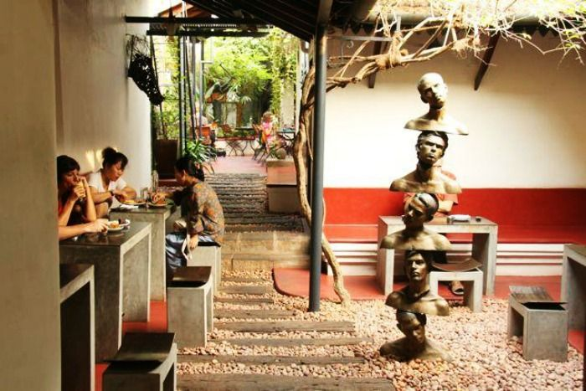**[http://d2847ql9t214mi.cloudfront.net/wp-content/themes/harmony/img/click1.png](javascript:void(0))**

Food or no food, Kashi Art Café is a must visit in Kochi. The casual vibe and the artsy setting of the place has turned it into an attraction in itself. However, the food here is also terrific!

**Speciality:** Western breakfast and coffee  
**Location:** Fort Kochi, Kochi  
**Ratings:** 4.5 stars  
[Ratings / Reviews on TripAdvisor](http://www.tripadvisor.in/Restaurant_Review-g297633-d983136-Reviews-Kashi-Kochi_Cochin_Kerala.html)

**12. Le Sante Café**

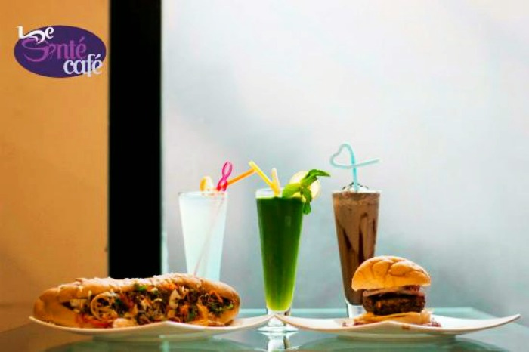**[http://d2847ql9t214mi.cloudfront.net/wp-content/themes/harmony/img/click1.png](javascript:void(0))**

Come here to hog on the best burgers in the town! Located in the heart of Kozhikkode town, Le Sante Café is awesome for hangout and a quick bite.

**Speciality:** Burgers, Waffles, ice-creams and desserts  
**Location:** NIT Mukkam Road, Kozhikode  
**Ratings:** 4.5 stars  
[Ratings / Reviews on Facebook](https://www.facebook.com/lesantecafe)

**13. German Bakery (Waves)**

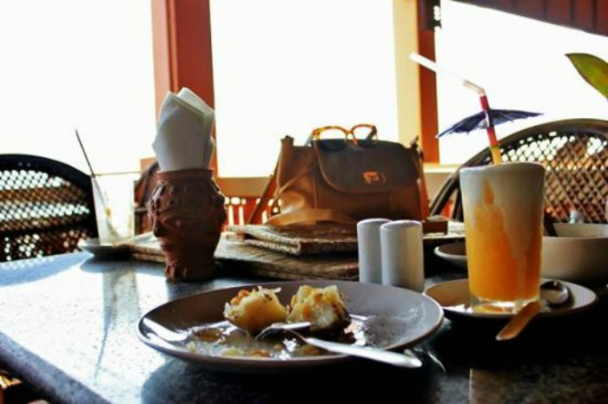**[http://d2847ql9t214mi.cloudfront.net/wp-content/themes/harmony/img/click1.png](javascript:void(0))**

The most popular hangout in town, the German Bakery has the best breakfast menu. You can spend hours on the on an airy, sunburnt-orange balcony sipping coffee and nibbling on their delectable food.

**Speciality:** Curries, seafood, tofu and pizzas  
**Location:** Lighthouse Beach, Kovalam

JAIPUR

**1. Sanjay Omelette**  
Not just for breakfast, you can eat eggs all day, every day and they show you how. Don’t let the humble atmosphere steer you off course. The place is owned by Mr. Sanjay Sharma who was also one of the participants of MasterChef India and has been serving the city for over two decades. Tucked away in the backstreets, it does a winning line in everything made with eggs – from curries to omelette, parathas to rolls and even pizzas. The egg pizza is quite something and my personal favourite. You’ll be amazed to see the variety of dishes and flavours. Burgers, sandwiches, salads or soup – just put an egg on it. The Obama Omelette is another attraction, made with white and brown bread and topped with melted cheese. *Drool*  
  
*Address:  B 18 & 19, Janta Store, Bapu Nagar*  
  
**2. 1135 AD**  
This restaurant lives up to its name. The imperial ambience with regal chairs, gold enameled walls and magnificent tables takes you back in time. The elegant decor and romantic outdoors create a perfect ambience to watch the sun go down in style. The stunning view makes you forget yourself and so does the food. Their menu comprises a mix of Mughlai, Rajasthani and North Indian delights. Food is served on silver plates with silver cutlery to reflect royalty. The Lal Maas really stood out. It was so tender that the meat was falling off at the bone. The Jungli Maas, Sula Biryani and Paneer Aftab certainly hit the spot.  
  
*Address: Level 2, Jaleb Chowk, Near Sheela Mata Temple, Amer Palace, Amer*

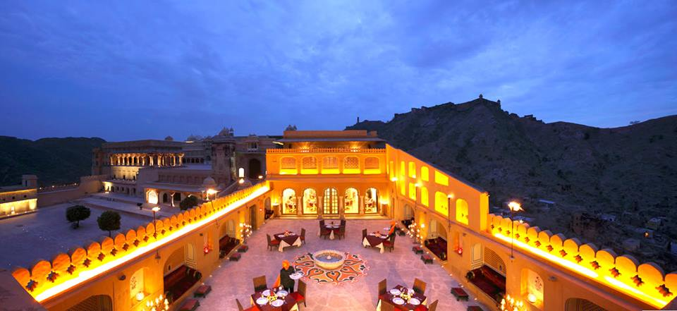Photo Credit: Facebook/1135 A.D. Amber

**3. Anokhi Cafe**  
This cheerful bistro with nostalgic decor is a local favourite. There is something about its monastic simplicity. It’s a great place for a quick escape with the healthiest food in town. The café serves freshly baked breads, well-dressed salads, loaded sandwiches and cheesecakes with organic ingredients grown locally at their farm. The Coffee Cake with coffee cream filling and Khao Suey are worth going back for. Wash it all down with one of their freshly squeezed juices. This place is ideal for those feeling weary after a hectic tour.  
  
*Address: C 11, 2nd Floor, KK Square, Prithviraj Road, C Scheme*

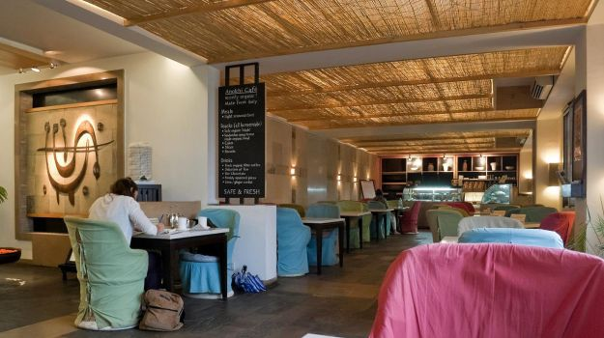

Photo Credit: Facebook/Anokhi Cafe Jaipur  
  
**4. Laxmi Mishtan Bhandar**  
Just around the corner of the busy Johari Bazaar, LMB offers some excellent local eats. It has always been in the sweet spot (pun intended!).  It is famous throughout town for Rajasthani specialties like a variety of ghewars and milk cake. From kachoris to Mirchi Vada and everything in between, soothe your street food cravings here. It’s a pure vegetarian restaurant; the idea was to serve satvik food that can also be offered at temples. For local flavour, try their Rajasthani thali with Dal-Bhati-Churma and Paneer Ghewar.  
  
*Address: 100, Johari Bazaar*  
  
**5. Tapri Central**  
This lively cafe is definitely a hotspot for the young lot. This easygoing little place serves home-style quick grub without a major wound to your wallet. The interiors are edgy and the menu is very creative with a new-wave of fusion treats like Flowery Flirt Tea, Cheese Puchkas and Pesto Khakra Pizzas.  Familiar ingredients are thrown together in surprising combinations. The Ishpecial Vada Pav with cheese and chutneys is a real steal.  
  
*Address: B4 E, 3rd Floor, Surana Jewellers, Opposite Central Park, Prithviraj Road, C Scheme*

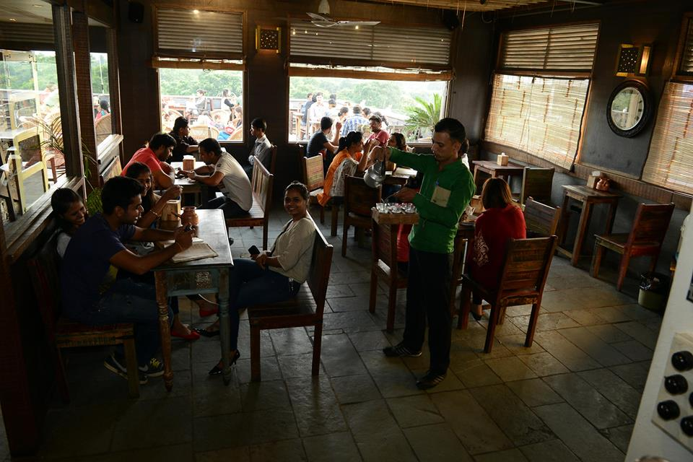

Photo Credit: Facebook/New Tapri  
  
**6. Brown Sugar**  
With woody interiors, hip music and good coffee, Brown Sugar is another chic café. It’s a great place if you’re looking to catch up with some old friends. The bakery keeps the counter filled with breads, cakes, pizzas and more. The Nutella Pancakes were divine.  
*Address: Aurum Apartment, Tilak Marg, C Scheme, Jaipur*

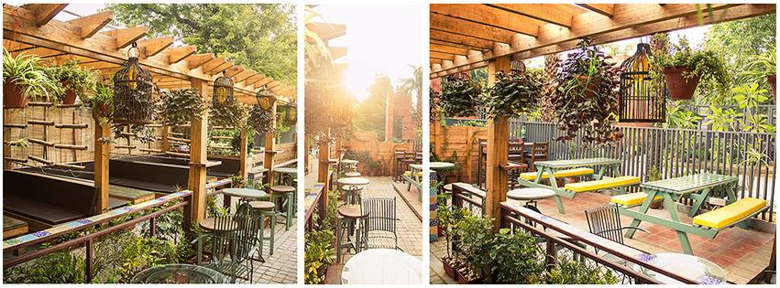

Photo Credit: Facebook/Brown Sugar - Bakers & Cafe  
  
*(*[*The Parsi Trail: Top 7 Parsi Restaurants In Mumbai​*](http://food.ndtv.com/reviews/the-parsi-trail-top-7-parsi-restaurants-in-mumbai-772959?pfrom=home-foodtrails&reviews)*)*  
  
**7. Rawat Mishtan Bhandar**  
This outlet is best known for its Onion and Dal Kachoris. This quintessential street snack exemplifies the earthy flavours of Rajasthan’s cuisine. At the very sight of these crunchy-golden kachoris, I was sold. Layers of crispness stuffed with browned onions and lentils will make it difficult to tear yourself away.  
  
*Address: Opposite Polovictory Cinema, Station Road, Sindhi Camp*  
  
**8. Spice Court**  
Set in a pristine courtyard, this place serves up a fantastic array of Rajasthani dishes. The Jungli Maas is a traditional tribal recipe where mutton is cooked with red chillies, garlic, onions and ghee.  It was deep in flavour and left my lips tingling. The Lal Maas was excellent. Also, try the Keema-Bati. It is another version of the Dal-Bati where flour rounds are fried and stuffed with a spicy keema-mix.  
  
*Address:  Achrol House, Jacob Road, Civil Lines, Jaipur*

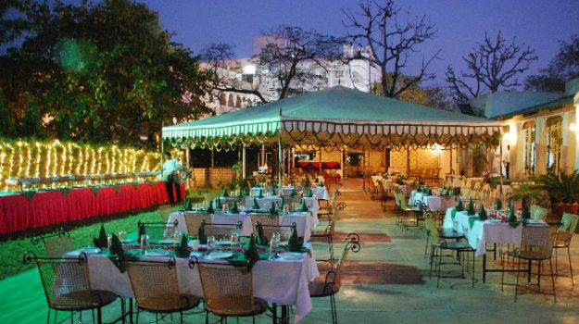

Photo Credit: Facebook/Spice Court Restaurant  
  
**9. Dragon House**  
This critically acclaimed restaurant is known for some great Asian food with focus on Thai and Chinese cuisine. Inside it’s not much of a looker but the menu is good. The dim sums and Thai salads are delicious picks, though I found the prices of some dishes a bit steep. Come here for a Thai-style meal to break from the monotony.  
  
*Address: Khasa Kothi Circle, M.I. Road  
  
(*[*Food Trail: Our Hunt For The Best Chole Bhature in Delhi​*](http://food.ndtv.com/reviews/food-trail-our-hunt-for-the-best-chole-bhature-in-delhi-774831)*)*